OBJECTIVE QUESTIONS

Question 1: What is the total no. of tables present in the data?

Solution:

Final Answer (if any)
The Total No. of Tables present in the Data are Two (2).
- Raw Data.
- Country Description.

Approach (if any):
Count of data sheets.

Charts & Tables (if any):
- Table / Chart Name:
<Name of the table or chart used>
- Description:
<What the table or chart represents>

Question 2: What is the total no. of attributes present in the data?

Solution:

Final Answer (if any):
22 Attributes in Raw Data and 2 Attributes in Country Description Therefore Total count is 24.

Approach (if any):
Counted the total numbers of Columns in Raw data and Country description

Charts & Tables (if any):
- Table / Chart Name:
<Name of the table or chart used>
- Description:
<What the table or chart represents>

Question 3: How many categorical columns are there in the data? [Search about categorical and continuous data, and try to answer this question]

Solution:

Final Answer (if any):
15 Categorical columns
Approach (if any):
Restaurant Name, City, Address, Locality, Locality Verbose, Cuisines, Currency, Country Name, Average Cost for two with currency symbol, has Table booking, has Online delivery, is delivering now, Switch to order menu, Country Code, Price-range.

Charts & Tables (if any):
- Table / Chart Name:
<Name of the table or chart used>
- Description:
<What the table or chart represents>

Question 4: The data consists of some inconsistent and missing values so ensure that the data used for further analysis is cleaned.

Solution:
Final Answer (if any):
The dataset was cleaned by handling missing values, standardizing inconsistent entries, trim and proper unwanted space, removing duplicates, fixing data types and treating outliers.
As a Result of deleting 9 cuisines rows there are 9542 restaurants are there out of 9551.
And 2.89 average rating.

Approach (if any):
- Missing Cuisines Values: 9 rows with missing 9 cuisines values had been deleted from the data.
- Longitude and Latitude values: Replaced 0 with blanks/null values to avoid mapping to invalid address.
- Average-cost-for-two: Created Another column as Imputed Average-Cost-for-two for 0 cost in Average-cost-for-two columns. Imputed Average-Cost-for-two By Applying
  - =IF(R2=0 ,MEDIAN(FILTER($R$2:$R$9543,$R$2:$R$9543>0)),R2).
- Trim: created new columns for Restaurant Name, Locality, Locality Verbose and city and used =proper(trim) in those new columns copied and pasted values only and deleted all old columns with same name.
- Date key-Opening: Used Find and Replace in find “_” and replaced it with “-” and then from ribbon Selected data in data selected number and date “DD-MM-YYYY”.

Charts & Tables (if any):
- Table / Chart Name:
<Name of the table or chart used>
- Description:
<What the table or chart represents>

Question 5: Using the Lookup functions, fill up the countries in the original data using the country code.

Solution:

Final Answer (if any):
The blank Country column in the original data was filled by Country Name looking up each row's country code in a country code reference table using XLOOKUP By Applying Formula.

Approach (if any):
Apply a lookup function to the blank countries. In the Country column, look up the code in the reference table and return the country name. Using XLOOKUP:
=XLOOKUP(C2,'country description'!A$1:A$16,'country description'!$B$1:$B$16)

Charts & Tables (if any):
- Table / Chart Name:
<Name of the table or chart used>
- Description:
<What the table or chart represents>

Question 6: Create a table to represent the number of restaurants opened in each country.

Solution:
Final Answer (if any):
The table shows the number of restaurants in each country, created after the country names were filled in using the country codes. The dataset covers 15 countries and 9,542 restaurants in total.

Approach (if any):
- Use the cleaned data. Start from the cleaned dataset, where the Country column has been filled using the country code lookup (Question 5), so every row has a country.
- Insert a PivotTable. Select the data range, then go to Insert → PivotTable and place it on a existing sheet.
- Set up the fields.
  - Drag Country to the Rows area.
  - Drag Restaurant ID to the Values area and set it to Count.
  - Rename the value field to Number of Restaurants.
- Show the Grand Total. Enable it under PivotTable Design → Grand Totals → On for Rows and Columns.
- Create the chart. Click inside the pivot table and go to Insert → Column Chart → Clustered Column.
- Title: "Count of Restaurant".
- X-axis title: "Country". Y-axis title: "No. Of Restaurants".
- Turn on data labels.
- Remove the legend and hide the field buttons.
- Validate. Check that the Grand Total (9,542) equals the total number of rows in the cleaned Data.

Charts & Tables (if any)

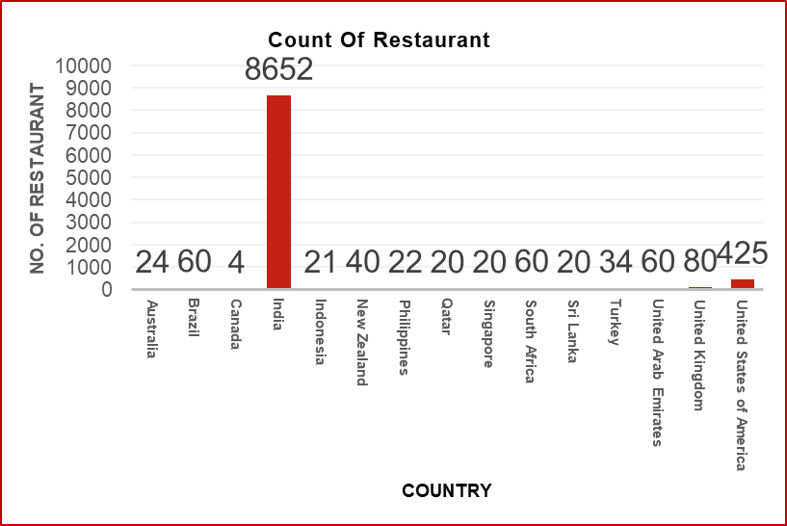

Country | Number Of Restaurants
Australia | 24
Brazil | 60
Canada | 4
India | 8652
Indonesia | 21
New Zealand | 40
Philippines | 22
Qatar | 20
Singapore | 20
South Africa | 60
Sri Lanka | 20
Turkey | 34
United Arab Emirates | 60
United Kingdom | 80
United States of America | 425
Grand Total | 9542

Question 7: Also, the management wants to look at the number of restaurants opened each year, so provide them with something here.

Solution:

Final Answer (if any):
Between 2010 and 2018, a total of 9,542 restaurants were opened.
Approach (if any):
- Use the cleaned data. Start from the cleaned dataset, where the date column was converted to a single consistent format.
- Extract the year. Add a helper column next to the opening date column:
  - =YEAR(D2)
  - Fill it down for all rows using fill handle.
- Insert a PivotTable. Select the whole data, then go to Insert → PivotTable.
- Drag Year to Rows.
- Drag Restaurant ID to Values and set it to Count.
- Rename the value field to Restaurant Opened.
- Show the Grand Total. Turn on Grand Totals so the table adds up to 9,542.
- Create the chart. Select the pivot table and go to Insert → Line Chart with Markers.
  - Title: "Restaurant Opened Per Year".
  - Y-axis title: "No. Of Restaurants". X-axis title: "Year".
  - Turn on data labels so each year's count is visible.
- Validate. Check that the sum of the yearly counts equals the total number of rows in the data.

Charts & Tables (if any):
Year | Restaurant Opened
2010 | 1079
2011 | 1096
2012 | 1022
2013 | 1059
2014 | 1049
2015 | 1023
2016 | 1026
2017 | 1086
2018 | 1102
Grand Total | 9542

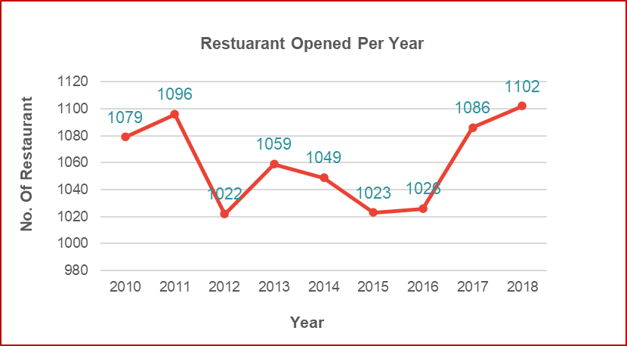

Question 8: What is the total number of restaurants in India in the price range of 4?

Solution:

Final Answer (if any):
There are 388 restaurants in India with a price range of 4.

Approach (if any):
Formula: =COUNTIFS('Cleaned Data'!W:W,"India",'Cleaned Data'!P:P,"4")

- Use the cleaned data. Start from the Cleaned Data sheet.
- Identify the two criteria columns.
  - Column W holds the Country, and the condition is "India".
  - Column P holds the Price Range, and the condition is "4".
- Apply COUNTIFS. The function counts only the rows where both conditions are true at the same time.
  - 'Cleaned Data'!W:W,"India" is the first range and criterion (Country = India).
  - 'Cleaned Data'!P:P,"4" is the second range and criterion (Price Range = 4).
- Read the result. The formula returns 388, the number of Indian restaurants in the highest price range.
- Validate (optional). Cross-check with a PivotTable: put Country in Filters (India), Price Range in Rows, and Count of Restaurant ID in Values. The row for price range 4 should also show 388.

Charts & Tables (if any):
- Table / Chart Name:
<Name of the table or chart used>
- Description:
<What the table or chart represents>

Question 9: What is the average number of voters for the restaurants in each country according to the data?

Solution:

Final Answer (if any):
Indonesia has the highest average votes per restaurant (772), followed by the United Arab Emirates (494) and Turkey (431). Brazil has the lowest (20). The overall average is 157 votes. India, with the most restaurants, averages 137.

Approach (if any):
- Use the cleaned data. Start from the Cleaned Data sheet.
- Insert a PivotTable. Select the data range, go to Insert → PivotTable, and place it on a new sheet.
- Set up the fields.
  - Drag Country to Rows.
  - Drag Votes to Values.
  - Click the value field → Value Field Settings → change Sum to Average.
  - Rename the field to Average Votes.
- Format the numbers. Set Number Format to 0 decimal places so the values appear as whole numbers (e.g. 772).
- Sort the table. Right-click any value → Sort → Sort Smallest to Largest, so Brazil (20) is at the top and Indonesia (772) at the bottom.
- Read the Grand Total. In a pivot table, the Grand Total for an Average is the average over all rows (157), not the sum or the average of the country averages.
- Create the chart. Click inside the pivot table and go to Insert → Bar Chart → Clustered Bar.
  - Title: "Average Number of Voters in Each Country".
  - Turn on data labels (Chart Design → Add Chart Element → Data Labels → Outside End).
  - Axis title: "Average Of Voters".
  - Remove the legend and hide the field buttons.
  - Sort in descending order so the largest bar is at the top.
- Validate (optional). Cross-check one country with a formula:

Charts & Tables (if any):
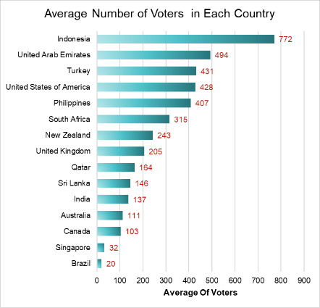

Country | Average Votes
Brazil | 20
Singapore | 32
Canada | 103
Australia | 111
India | 137
Sri Lanka | 146
Qatar | 164
United Kingdom | 205
New Zealand | 243
South Africa | 315
Philippines | 407
United States of America | 428
Turkey | 431
United Arab Emirates | 494
Indonesia | 772
Grand Total | 157

Question 10: Calculate the average rating for all the restaurants that have price_range < 4 and provide online delivery. Use only the “IF” function, Logical Operators, and Aggregation functions to solve this problem. [Note: Don’t use Conditional aggregation in this question.]

Solution:

Final Answer (if any):
3.27

Approach (if any):
Formula: ==ROUND(AVERAGE(IF(('Cleaned Data'!P2:P9543<4)*('Cleaned Data'!M2:M9543="Yes"),'Cleaned Data'!T2:T9543)),2)
- Applied ARRAYFORMULA combining AVERAGE, IF, and Boolean multiplication (*) acting as a logical AND operator.
- Condition 1 checks for Price range < 4 (Price tiers 1, 2, and 3).
- Condition 2 checks Has Online delivery = "Yes".
- The array formula extracts qualifying ratings and aggregates them without using conditional functions like AVERAGEIFS.

Charts & Tables (if any):
- Table / Chart Name:
<Name of the table or chart used>
- Description:
<What the table or chart represents>

Question 11: Using Conditional formatting highlight the rows of restaurants that are located in the countries or cities that you’ve suggested to the management for opening new restaurants.

Solution:

Final Answer (if any):
Rows of restaurants in the seven suggested countries (Philippines, Australia, Canada, Sri Lanka, Qatar, Singapore and Indonesia) were highlighted using conditional formatting. A total of 131 rows are highlighted.
Approach (if any):
- Selected the entire data range A2:Y9543 on the Cleaned Data sheet.
- Opened Format > Conditional Formatting and set the rule type to "Custom formula”.
- Formula =OR($V2="Philippines", $V2="Australia", $V2="Canada", $V2="Sri Lanka", $V2="Indonesia",$V2=”Qatar”,$V2=”Singapore”)
- The $V locks the Country column so the whole row is highlighted, and OR highlights a row if its country is any one of the five. The highlighted rows were verified against the pivot table total of 131.
- Set formatting style to blue fill with dark text for clear visual emphasis.

Charts & Tables (if any):
- Table / Chart Name:
<Name of the table or chart used>
- Description:
<What the table or chart represents>

Question 12: Create a new customized price column that consists of the abbreviation/symbol of the currency along with the Average_cost_for_two value. [Use string operations to do this task]

Solution:

Final Answer (if any):
A new column, "Average-cost-for-two with currency symbol," was created. It combines each restaurant's currency symbol with its average cost for two values, for example Rs. 300, $ 30 or £ 25.

Approach (if any):
Formula:
=SUBSTITUTE(MID(K2,FIND("(",K2)+1,FIND(")",K2)-FIND("(",K2)-1),
"Œ£","£")&" "&R2

FIND locates the positions of "(" and ")" in the Currency column (Column K).
MID extracts the currency symbol/abbreviation between the brackets, for example "Rs."
from "Indian Rupees(Rs.)".
SUBSTITUTE replaces the corrupted pound symbol "Œ£" with the correct "£".
The & operator joins the symbol, a space, and the Average Cost for Two value (Column R).
The formula was dragged down to apply to all rows.

Charts & Tables (if any):
- Table / Chart Name:
<Name of the table or chart used>
- Description:
<What the table or chart represents>

Question 13: How can you create an array formula in Excel or Google Sheets to count the number of restaurants listed that do not offer online delivery, are in the lowest price range, and have an average cost for two people less than or equal to 250 Indian Rupees?

Solution:
Final Answer (if any):
1676

Approach (if any):

1. Formulated a multi-condition boolean array formula:
=SUMPRODUCT(('Cleaned Data'!$M$2:$M$9543="No")*('Cleaned Data'!$P$2:$P$9543=1)*('Cleaned Data'!$S$2:$S$9543<=250)*('Cleaned Data'!$W$2:$W$9543="India"))
Columns: M = Has_Online_delivery, P = Price_range, S= Imputed Average_Cost_for_two,
W= Country Name.
3.Answer: 1,676.
4. Assumption to state: "250 Indian Rupees" is applied only to India-currency rows, so the formula filters Country = India. Without that filter the result would be 1,813 because it would also count other currencies' small numbers.

Charts & Tables (if any):
- Table / Chart Name:
<Name of the table or chart used>
- Description:
<What the table or chart represents>

SUBJECTIVE QUESTIONS

Question 1: Suggest a few countries where the team can open newer restaurants with lesser competition. Which visualization/technique will you use here to justify the suggestions?

Solution:

Approach:
- Used the number of restaurants in each country as the measure of competition. Fewer restaurants mean less competition.
- Low competition alone isn't enough, because a country may have few restaurants due to weak demand. So, added two demand and quality indicators: Average Rating (customer satisfaction) and Average Votes (customer engagement) with count of restaurant id.
- Selected the seven countries with the lowest restaurant counts from the cleaned data (Canada, Sri Lanka, Indonesia, Philippines, Australia, Qatar, Singapore). India (8,652) and the USA (434) are heavily saturated, so they were excluded.
- Technique and visualization: a pivot table (Country vs Restaurant Count, Average Rating, Average Votes) and a combo chart (columns for Restaurant Count and Average Rating, a line for Average Votes). It shows competition, quality and demand together, so the best markets can be compared Easily and get to know about real challenges.

Charts & Tables:

Row Labels | Count of Restaurant ID | Average of Rating | Average of Votes
Australia | 24 | 3.66 | 111
Canada | 4 | 3.58 | 103
Indonesia | 21 | 4.30 | 772
Philippines | 22 | 4.47 | 407
Qatar | 20 | 4.06 | 164
Singapore | 20 | 3.58 | 32
Sri Lanka | 20 | 3.87 | 146
Grand Total | 131 | 3.97 | 268

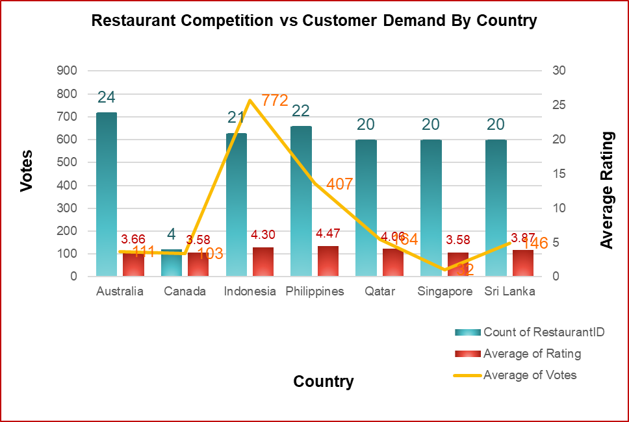

Insights:
- Indonesia has only 21 restaurants but the highest average votes (772) and a strong rating (4.3). Demand is very high compared with the supply of restaurants.
- Philippines has the highest average rating (4.5) and strong votes (407) with just 22 restaurants. Customers are highly satisfied and engaged.
- Qatar has 20 restaurants with a strong average rating (4.1) and moderate votes (164). Customers are fairly satisfied and engaged, so it's a decent market with room for a new entrant.
- Singapore has 20 restaurants but a low rating (3.6) and the lowest votes of all (32). Customer engagement is very weak, so the market looks less attractive despite low competition
- Sri Lanka (20 restaurants) has moderate rating (3.9) and votes (146), so demand is average.
- Australia has the most restaurants of the five (24) and low votes (111) and rating (3.7), so the market is less attractive.
- Canada has the fewest restaurants (4) but the lowest rating (3.6) and low votes (103). Competition is minimal, but customer interest looks weak and the sample is very small.
- All Seven countries have far fewer restaurants than India (8,652), so competition is low in each.

Recommendations:
- Open new restaurants first in Indonesia. It has the highest demand (772 average votes) with low competition.
- Philippines is the second priority. Its top rating (4.5) shows customers are satisfied and the market is receptive.
- Qatar has good rating, moderate demand.
- Sri Lanka is a moderate option. Consider it after the first three, with a smaller launch.
- Treat Canada Singapore and Australia cautiously. Canada has low engagement and very little data, and Australia has comparatively more restaurants and low votes. Try a pilot outlet or do more research before investing.
- Avoid India and the USA, which are already saturated.

Question 2: Come up with the names of States and cities in the suggested countries suitable for opening restaurants.

Solution:
Approach:
- Selected the Seven suggested countries Australia, Canada, Indonesia, Philippines, Sri Lanka, Qatar, Singapore.
- Create a pivot table with Country and City in Rows and Count of Restaurant ID in Values , Average of Rating in values ,Average of Average cost for two in values.
- Used the count per city to check competition (fewer restaurants = less competition).
- Cities with only one restaurant are the least competitive.

Charts & Tables:
Country/City | Count of Restaurant ID | Average of Rating | Average of Average-cost-for-two in Rs.
Australia | 24 | 3.7 | 2311
Armidale | 1 | 3.5 | 1919
Balingup | 1 | 3.2 | 1919
Beechworth | 1 | 4.6 | 1919
Dicky Beach | 1 | 3.6 | 672
East Ballina | 1 | 4.1 | 1919
Flaxton | 1 | 3.5 | 2878
Forrest | 1 | 3.7 | 1919
Hepburn Springs | 2 | 3.8 | 1295
Huskisson | 1 | 4.1 | 1919
Inverloch | 1 | 3.7 | 672
Lakes Entrance | 1 | 3.8 | 672
Lorn | 1 | 3.6 | 1919
Macedon | 1 | 3.5 | 1919
Mayfield | 1 | 2.9 | 1919
Middleton Beach | 1 | 3.8 | 2878
Montville | 1 | 2.4 | 2878
Palm Cove | 1 | 4.4 | 2878
Paynesville | 1 | 2.6 | 11513
Penola | 1 | 3.4 | 1919
Phillip Island | 1 | 3.7 | 1919
Tanunda | 1 | 4.4 | 2878
Trentham East | 1 | 4.1 | 1919
Victor Harbor | 1 | 3.6 | 1919
Canada | 4 | 3.6 | 3478
Chatham-Kent | 1 | 3.7 | 2399
Consort | 1 | 3.0 | 2399
Vineland Station | 1 | 4.3 | 6716
Yorkton | 1 | 3.3 | 2399
Indonesia | 21 | 4.3 | 1490
Bandung | 1 | 4.2 | 795
Bogor | 2 | 3.9 | 848
Jakarta | 16 | 4.4 | 1635
Tangerang | 2 | 4.3 | 1325
Philippines | 22 | 4.5 | 11280
Makati City | 2 | 4.7 | 8073
Mandaluyong City | 4 | 4.6 | 14040
Pasay City | 3 | 4.4 | 23400
Pasig City | 3 | 4.6 | 6552
Quezon City | 1 | 4.8 | 5616
San Juan City | 2 | 4.3 | 5967
Santa Rosa | 2 | 3.8 | 5792
Tagaytay City | 1 | 4.5 | 8424
Taguig City | 4 | 4.5 | 12110
Qatar | 20 | 4.1 | 5891
Doha | 20 | 4.1 | 5891
Singapore | 20 | 3.6 | 14943
Singapore | 20 | 3.6 | 14943
Sri Lanka | 20 | 3.9 | 689
Colombo | 20 | 3.9 | 689
Grand Total | 131 | 4.0 | 5949

Insights:
- Philippines has the highest ratings (4.5 average) across 22 restaurants and 10 cities. Prices are high (avg. Rs 11,280), which suggests a premium-dining market.
- Indonesia has strong ratings (4.3) at low prices (Rs 1,490), but 16 of its 21 restaurants are in Jakarta, so Jakarta is crowded.
- Qatar rates 4.1 with moderate prices (Rs 5,891). All 20 restaurants are in Doha, so it's a single-city market.
- Sri Lanka is the cheapest market (Rs 689) with a decent 3.9 rating. All 20 restaurants are in Colombo.
- Singapore has weak ratings (3.6) and the highest prices (Rs 14,943), so it's expensive without delivering quality.
- Australia and Canada are fragmented, with one restaurant per city and inconsistent ratings. Those averages rest on very little data.

Recommendations:
- Philippines (priority 1)
Quezon City: 1 restaurant, 4.8 rating, Rs 5,616. This is the best low-competition, high-satisfaction gap.
Tagaytay City: 1 restaurant, 4.5 rating.
Pasig City: 3 restaurants, 4.6 rating, Rs 6,552. Moderate pricing.
Makati City and Taguig City: strong ratings (4.7 and 4.5) but costly, so suited to a premium concept.
Avoid Pasay City: Rs 23,400 is an outlier.
- Indonesia (priority 2)
Bandung: 1 restaurant, 4.2 rating, Rs 795. This is the cheapest entry.
Tangerang: 2 restaurants, 4.3 rating, Rs 1,325.
Jakarta: a 4.4 rating shows high demand, but 16 restaurants means heavy competition. It's only worth it with a differentiated concept.
- Qatar (priority 3)
Doha is the only option. A 4.1 rating with moderate prices is workable, but the competition is real, so differentiate.
- Sri Lanka (moderate)
Colombo: low-cost, mid-rated. Launch small.
- Australia (pilot only)
Best candidates: Beechworth (4.6), Palm Cove and Tanunda (4.4), Huskisson, East Ballina and Trentham East (4.1).
Avoid Montville (2.4), Paynesville (2.6) and Mayfield (2.9).
- Canada
Vineland Station rates 4.3 but costs Rs 6,716, based on a single restaurant.
- Singapore has only one city (Singapore) with 20 restaurants, a low 3.6 rating and the highest average cost (Rs 14,943). It is a high-cost, high-competition market with weak satisfaction, so enter only through a pilot outlet with a differentiated concept after further research."

Question 3: According to the countries you suggested, what is the current quality regarding ratings for restaurants that are open there?

Solution:

Approach:

- Create a pivot table with Country in Rows and Average of Rating in Values, rounded to 2 decimals.
- Selected the Seven suggested countries Australia, Canada, Indonesia, Philippines,
Sri Lanka, Qatar, Singapore.
- Sorted from lowest to highest and plotted a bar chart.
- Grand Total (3.97) is the average rating over all 131 restaurants in these seven countries.

Charts & Tables:

Country Names | Average of Rating
Canada | 3.58
Singapore | 3.58
Australia | 3.66
Sri Lanka | 3.87
Qatar | 4.06
Indonesia | 4.30
Philippines | 4.47
Grand Total | 3.97

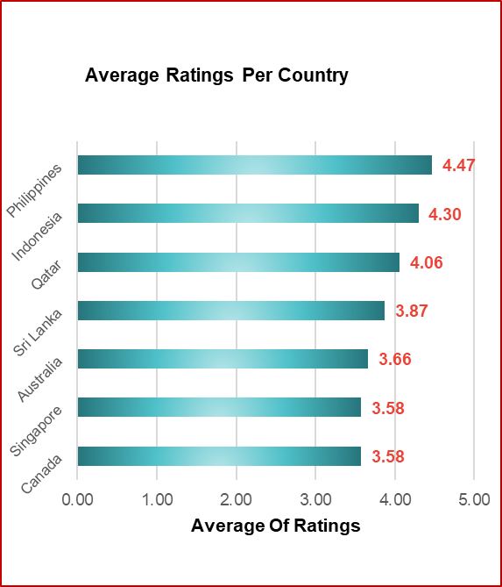

Insights:

- Philippines (4.47) and Indonesia (4.30) have the highest ratings, so restaurant quality is already strong there. A new entrant must match that standard for competitive purpose.
- Qatar (4.06) is above the overall average (3.97), so quality is good but not outstanding.
- Sri Lanka (3.87) is just below the average, so quality is moderate.
- Australia (3.66), Canada (3.58) and Singapore (3.58) are the lowest. Existing restaurants are rated poorly, which leaves room for a better-quality restaurant to stand out.
- The gap between the top (4.47) and bottom (3.58) is under one point, so quality is fairly even across the seven countries.

Recommendations:
- Philippines and Indonesia: Enter with a high-quality offering. Customers here are satisfied and rate generously, so only strong quality will compete.
- Qatar: Enter with a quality-focused or premium concept. The rating is above average, so there is room to do better.
- Sri Lanka: Treat it as a moderate-quality market. A well-run restaurant can outperform existing ones.
- Australia, Canada and Singapore: Low ratings suggest an opportunity to win on quality. Earlier data showed weak votes in these markets (Singapore's 32 is the lowest), so low ratings may reflect weak demand rather than a gap you can fill.

Question 4: Also, what is the current expenditure on food in the suggested countries, so we can keep our financial expenditure in control?

Solution:

Approach:
- Selected the Seven suggested countries Australia, Canada, Indonesia, Philippines, Sri Lanka Qatar, Singapore.
- Create a pivot table with Country in Rows, and Average of Average Cost for Two in Rs.in values and Average of Rating in Values.
- Used average cost for two as the measure of current food expenditure per restaurant.
- Plotted a column chart comparing average cost across the seven countries.
- Costs are in each country's local currency, so they cannot be compared directly across countries.

Charts & Tables:

Country | Average of Average Cost For Two | Average of Rating
Singapore | 14943 | 3.6
Philippines | 11280 | 4.5
Qatar | 5891 | 4.1
Canada | 3478 | 3.6
Australia | 2311 | 3.7
Indonesia | 1490 | 4.3
Sri Lanka | 689 | 3.9
Grand Total | 5949 | 3.97

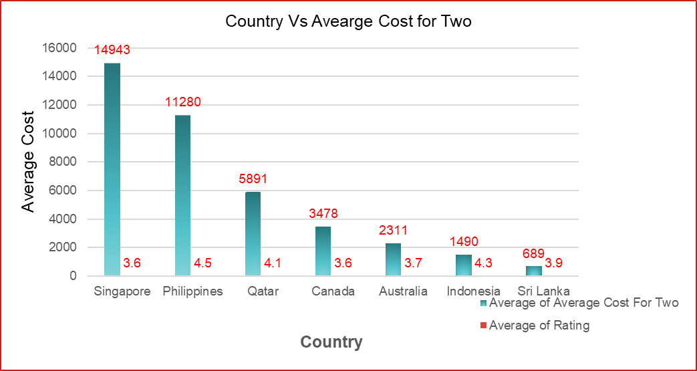

Insights:

- Singapore is the most expensive market (14943) but has a low Rating (3.6) so high prices are not considered as a satisfaction or engagement.
- Philippines is the second most expensive market with average cost (11,280) with the highest rating (4.5) so customers accept premium pricing when quality is good.
- Qatar has a mid-to-high cost (5,891) and a good rating (4.1), a healthy balance of spend and satisfaction.
- Canada has 3,478 with the lowest rating 3.58.
- Australia: 2,311, with a below-average rating 3.66.
- Indonesia: 1,490, with a high rating 4.30.
- Sri Lanka: lowest cost 689, with an average rating 3.87.
- Higher cost does not always mean a higher rating. Indonesia has a low cost but a high rating, while Canada has a high cost but a low rating.

Recommendations:
- Convert all costs to one currency before comparing countries, so the budget comparison is fair.
- Philippines (first choice, premium): It has the highest rating (4.5) and the second-highest cost (11,280). Customers pay more and still rate highly, so a quality premium concept should work.
- Indonesia (first choice, volume): It has a strong rating (4.3) at a low cost (1,490). Use affordable pricing and aim for high customer volume, backed by its highest demand (772 votes).
- Qatar (third choice): It has a good rating (4.1) and a mid-to-high cost (5,891). Test it with one quality-focused outlet before expanding.
- Sri Lanka (low priority): Its cost is the lowest (689) with a moderate rating (3.9), so revenue per customer is low.
- Singapore (avoid or delay): It has the highest cost (14,943) but only a 3.6 rating and the lowest votes (32), so high prices aren't backed by customer satisfaction.
- Canada and Australia: Both are mid-to-low cost (3,478 and 2,311) with weak ratings (3.6 and 3.7), so they offer no clear advantage.

Question 5: Come up with the names of restaurants from the recommended states that are our biggest competitors and also those that are rated in the lower brackets, i.e. 1-2 or 2-3.

Solution:

Approach:
- Create a pivot table with Country and Restaurant Name in Rows, and Average of Rating and Max of Votes in Values.
- Selected the seven suggested countries Australia, Canada, Indonesia, Philippines, Sri Lanka, Qatar and Singapore.
- Biggest competitors: restaurants with high ratings (4.0 and above) and high votes, since votes show popularity and customer base.
- Low-rated restaurants: filtered the Rating field to show only restaurants rated below 3 (the 1-2 and 2-3 brackets).
- Built two tables, one for competitors and one for low-rated restaurants.

Charts & Tables:

Competitors Restaurant:
Country/Restaurant Name | Average of Rating | Max of Votes
Australia | 4.283333333 | 381
1918 Bistro & Grill | 4.4 | 339
5 Little Pigs | 4.1 | 40
Bridge Road Brewers | 4.6 | 237
Pig and Whistle | 4.1 | 87
The Belle General | 4.1 | 56
Vivo Bar and Grill | 4.4 | 381
Canada | 4.3 | 204
Lake House Restaurant | 4.3 | 204
Indonesia | 4.5 | 2212
3 Wise Monkeys | 4.2 | 395
Avec Moi Restaurant and Bar | 4.3 | 243
Flip Burger | 4.4 | 410
Lucky Cat Coffee & Kitchen | 4.3 | 458
MONKS | 4.2 | 259
Noah's Barn Coffeenery | 4.2 | 22
Satoo - Hotel Shangri-La | 4.6 | 873
Skye | 4.1 | 1498
Sushi Masa | 4.9 | 605
Talaga Sampireun | 4.9 | 2212
Toodz House | 4.6 | 1476
Union Deli | 4.6 | 903
Zenbu | 4.4 | 841
Philippines | 4.563157895 | 1070
Balay Dako | 4.5 | 211
Din Tai Fung | 4.4 | 336
Guevarra's | 4.2 | 458
Heat - Edsa Shangri-La | 4.4 | 270
Hobing Korean Dessert Cafe | 4.5 | 118
Izakaya Kikufuji | 4.5 | 591
Le Petit Souffle | 4.8 | 314
Locavore | 4.8 | 532
Mad Mark's Creamery & Good Eats | 4.2 | 488
NIU by Vikings | 4.7 | 535
Ooma | 4.9 | 365
Sambo Kojin | 4.8 | 229
Silantro Fil-Mex | 4.85 | 1070
Sodam Korean Restaurant | 4.3 | 223
Spiral - Sofitel Philippine Plaza Manila | 4.9 | 621
The Food Hall by Todd English | 4.5 | 618
Vikings | 4.2 | 677
Wildflour Cafe + Bakery | 4.4 | 392
Qatar | 4.4875 | 348
Gokul Gujarati Restaurant | 4.3 | 211
Gymkhana | 4.7 | 114
Mainland China Restaurant | 4.9 | 182
Paper Moon | 4.5 | 145
Sabai Thai - The Westin Doha Hotel & Spa | 4.3 | 73
Vine - The St. Regis | 4.4 | 67
Zaffran Dining Experience | 4.6 | 348
Zaoq | 4.2 | 189
Singapore | 4.15 | 35
Al'frank Cookies | 4.2 | 29
Fratini La Trattoria | 4.1 | 35
Sri Lanka | 4.277777778 | 286
Arabian Knights | 4.2 | 158
Burger's King | 4.1 | 199
Butter Boutique | 4.2 | 49
Cafe Beverly | 4.1 | 58
Carnival Ice Cream | 4.1 | 122
Cricket Club Cafe | 4.2 | 171
Ministry of Crab | 4.9 | 203
Simply Strawberries By Jagro | 4.5 | 146
The Sizzle | 4.2 | 286
Grand Total | 4.448333333 | 2212

Restaurant whose Ratings Below 3:

Country/Restaurant | Average of Rating
Australia | 2.633333333
Pier 70 | 2.6
Poets Cafe | 2.4
Star Buffet | 2.9
Canada | 3
Consort Restaurant | 3
Singapore | 3
Makansutra Gluttons Bay | 3
Sri Lanka | 2.45
Elite Indian Restaurant | 2.4
Queen's Cafe | 2.5
Grand Total | 2.685714286

Insights:
- Biggest competitors (high ratings, high votes):
- Indonesia has the strongest competition. Its top three have 1,476 to 2,212 votes, and Talaga Sampireu combines a 4.9 rating with the highest votes in the dataset. Sushi Masa (4.9, 805) and Satoo (4.6, 873) are also strong.
- Philippines is competitive on quality. Many restaurants rate 4.7 to 4.9 (Spiral, Ooma, Silantro, Locavore, Sambo Kojin), but only Silantro passes 1,000 votes. The market is crowded with highly rated places, though none is dominant.
- Qatar has the weakest competition. Its highest vote count is 348 (Zaffran), and the other restaurants are far lower. Mainland China (4.9) and Gymkhana (4.7) rate highly but have few votes (182 and 114).
- Australia: Competitors are decent (4.1 to 4.6) with moderate votes. Earlier data showed low overall demand (111 average votes).
- Sri Lanka: Competitors are mostly average (4.1 to 4.2), with Ministry of Crab (4.9) the standout. Quality is easy to beat.
- Canada: Only one competitor is listed, so the sample is too small to judge.
- Singapore has only two listed competitors, both with very low votes (29 and 35), which confirms weak demand there.

Recommendations:
- Qatar: Moderate competition, good quality and room to stand out. Aim for 4.6 or higher to beat Zaffran.
- Indonesia (highest reward): Enter with a differentiated concept and benchmark against Talaga Sampireu, Toodz House and Skye.
- Philippines: Enter only with a distinctive, high-quality concept, because 4.7 to 4.9 competitors are already common.
- Sri Lanka (low-risk option): Weak competitors make it easy to lead, but earlier data showed low spend per customer.
- Australia: Competition is moderate and demand is weak.
- Canada and Singapore (avoid or delay): The data is too thin, and Singapore shows very little demand.

Question 6: Which cuisines should we focus on in the newer restaurants to get better feedback? Does the choice of cuisines affect the restaurant ratings?

Solution:

Approach:
- Selected the Seven suggested countries Australia, Canada, Indonesia, Philippines, Sri Lanka, Qatar, Singapore.
- Create a pivot table with Country and Cuisines in Rows, and Average of Rating and Sum of Votes in Values.
- Compared cuisines by average rating, and used votes to check that the rating is based on enough customers.
- Shortlisted cuisines with high ratings (4.0 and above) and reasonable votes.

Charts & Tables:
Cuisines | Average of Rating | Sum of Votes
Australia | 3.658333333 | 2674
Asian | 2.9 | 11
Australian | 4.1 | 87
Bar Food, Modern Australian | 3.8 | 176
Bar Food, Steak | 3.5 | 25
Breakfast, Coffee and Tea | 3.7 | 115
Breakfast, Coffee and Tea, Modern Australian | 3.7 | 351
Breakfast, Modern Australian | 4.1 | 40
Burger, Coffee and Tea, Modern Australian | 3.7 | 100
Cafe | 3.8 | 87
Cafe, Australian | 3.7 | 29
Cafe, Coffee and Tea, Modern Australian | 3.8 | 192
Cafe, Coffee and Tea, Sandwich | 3.4 | 19
Coffee and Tea, Modern Australian | 2.4 | 193
Coffee and Tea, Tapas, Australian | 3.6 | 96
Coffee and Tea, Tea, Modern Australian | 3.6 | 29
Italian, Fusion, Cafe | 3.8 | 93
Mediterranean, Seafood | 4.4 | 381
Modern Australian | 2.9 | 37
Modern Australian, Australian | 4.4 | 339
Pizza, Bar Food | 4.6 | 237
Tea, Modern Australian | 3.5 | 37
Canada | 3.575 | 412
Asian | 3.3 | 26
Chinese, Canadian | 3 | 6
Italian, Mediterranean, Pizza | 4.3 | 204
Japanese, Sushi | 3.7 | 176
Indonesia | 4.2952 | 16214
Asian, Indonesian, Western | 4.6 | 873
Burger | 4.4 | 410
Cafe, Coffee and Tea, Western | 4.2 | 22
Cafe, Desserts, Beverages | 3.7 | 783
Cafe, Italian, Coffee and Tea, Western, Indonesian | 4.6 | 1476
Cafe, Western | 4.3 | 458
Desserts, Bakery, Western | 4.6 | 903
French, Western | 4.3 | 243
Indonesian | 3.7 | 155
Italian, Continental | 4.1 | 1498
Japanese | 4.2 | 395
Japanese, Sushi, Ramen | 4.4 | 841
Korean | 3.9 | 137
Peranakan, Indonesian | 4 | 1159
Seafood, Western | 3.7 | 483
Sunda, Indonesian | 4.9 | 5514
Sushi, Japanese | 4.9 | 605
Western, Asian, Cafe | 4.2 | 259
Philippines | 4.468181818 | 8963
American, Asian, Italian, Seafood | 4.5 | 618
American, Ice Cream, Desserts | 4.2 | 488
Asian, European | 4 | 520
Cafe, American, Italian, Filipino | 3.6 | 29
Cafe, Bakery, American, Italian | 4.4 | 392
Cafe, Korean, Desserts | 4.5 | 118
Chinese | 4.4 | 336
European, Asian, Indian | 4.9 | 621
Filipino | 4.5 | 1201
Filipino, Mexican | 4.85 | 1364
French, Japanese, Desserts | 4.8 | 314
Italian, Pizza | 4 | 72
Japanese | 4.5 | 591
Japanese, Korean | 4.8 | 229
Japanese, Sushi | 4.9 | 365
Korean | 4.3 | 223
Seafood, American, Mediterranean, Japanese | 4.7 | 535
Seafood, Asian, Filipino, Indian | 4.4 | 270
Seafood, Filipino, Asian, European | 4.2 | 677
Qatar | 4.06 | 3276
American, Tex-Mex | 3.8 | 155
Chinese | 4.9 | 182
European, Arabian, Japanese, Bakery, Desserts | 3.9 | 197
Indian | 4.18 | 1132
Indian, Street Food | 3.4 | 74
International | 4.05 | 125
Italian | 4.5 | 145
Kerala, Indian, Chinese, Bakery | 4 | 322
North Indian, Chinese, Turkish | 3.8 | 263
Pakistani | 4 | 272
Seafood, American | 4 | 180
Steak | 3.6 | 115
Steak, American | 4 | 41
Thai | 4.3 | 73
Singapore | 3.575 | 638
American | 3.1 | 34
American, Bakery, European, Burger, Fusion | 3.8 | 28
American, Japanese, Singaporean | 3.2 | 30
American, Mexican | 3.2 | 30
American, Steak | 4 | 33
Asian, Continental, Seafood | 3.8 | 30
Bakery | 4.2 | 29
Cafe | 3.7 | 33
Cafe, Spanish, Turkish, Greek | 3.2 | 33
Chinese, Continental, Singaporean | 3.4 | 34
Chinese, Seafood, Cantonese, Dim Sum | 3.9 | 34
Finger Food | 3.9 | 35
French | 3.85 | 68
French, Mediterranean, European | 3.8 | 33
Italian | 4.1 | 35
Italian, French, Bakery, Cafe | 3.2 | 29
Singaporean, Australian, German | 3.1 | 33
Singaporean, Chinese, Seafood, Malay, Indian | 3 | 25
Western, Fusion, Fast Food | 3.2 | 32
Sri Lanka | 3.87 | 2929
American, Chinese, North Indian | 2.5 | 93
American, Fast Food, Steak, Beverages | 4.2 | 286
American, Steak | 4 | 166
Cafe, Fast Food, Beverages | 3.8 | 81
Cafe, Italian | 3.6 | 83
Cafe, Sri Lankan, Continental, American | 4 | 209
Chinese | 3.4 | 118
Continental, American | 4.1 | 58
Continental, American, Seafood | 4.2 | 171
Desserts, Bakery | 4.2 | 49
Desserts, Ice Cream | 4.1 | 122
Fast Food | 4.1 | 199
Italian, Cafe, Desserts | 3.7 | 157
Juices, Desserts | 4.5 | 146
Malaysian, North Indian, Sri Lankan | 3.5 | 80
Middle Eastern, Arabian | 4.2 | 158
North Indian, Chinese, Sri Lankan | 2.4 | 240
Seafood | 4.9 | 203
Seafood, Italian | 4 | 196
Sri Lankan | 4 | 114
Grand Total | 3.97480916 | 35106

Insights:

  - Australia: Australia has an average rating of 3.66 across 2,674 votes, and cuisine clearly matters, with ratings ranging from 2.4 to 4.6. Pizza/Bar Food (4.6), Mediterranean/Seafood (4.4) and Modern Australian/Australian (4.4) are the strongest and are backed by solid votes. Coffee and Tea/Modern Australian (2.4, 193 votes) is the clear weak spot, and cafe and coffee concepts generally sit at an average 3.4-3.8. New restaurants should focus on pizza, Mediterranean seafood and Modern Australian concepts.
  - Canada: Canada averages 3.58 on only 412 votes, so its results are directional at best. Italian/Mediterranean/Pizza (4.3, 204 votes) is the only strong performer, while Asian (3.3) and Chinese/Canadian (3.0) lag, though on very few votes (26 and 6). Italian-style cuisine is the best tentative focus.
  - Indonesia: Indonesia averages 4.30 and has the highest engagement, with 16,214 votes (about 46% of the total). Sunda/Indonesian is both the highest rated and the most popular (4.9, 5,514 votes). Sushi/Japanese (4.9) and Western dessert or cafe concepts (4.6) also perform well, while generic cafe, plain Indonesian and Seafood/Western concepts are weaker at 3.7. Local Sunda food and Japanese or Western concepts are the safest focus.
  - Philippines: The Philippines has the highest average rating (4.47) across 8,963 votes, and even its lowest cuisine rates 3.6, so cuisine matters least here. Filipino/Mexican (4.85, 1,364 votes) and Filipino (4.5, 1,201 votes) are the strongest and most popular, with Japanese/Sushi and European/Asian/Indian also top rated at 4.9. Cafe/American/Italian/Filipino (3.6, only 29 votes) is the only real weak spot. Local Filipino concepts and Japanese or Asian fusion are the best focus.
  - Qatar: Qatar averages 4.06 on 3,276 votes, and cuisine clearly affects ratings, from 3.4 to 4.9. Indian (4.18, 1,132 votes) is the safest choice, with about 35% of all votes, while Chinese (4.9) and Italian (4.5) are the top rated but on moderate votes (182 and 145). Indian Street Food (3.4) and Steak (3.6) are the weakest. New restaurants should focus on Indian, Chinese and Italian.
  - Singapore: Singapore averages 3.58 on just 638 votes, only about 25-35 per cuisine, so its ratings are weak evidence. Bakery (4.2), Italian (4.1) and American/Steak (4.0) rate best, while mixed Singaporean concepts (3.0-3.1) rate worst. Focused single-cuisine concepts beat mixed multi-cuisine ones, so Bakery, Italian and Steak are the suggested focus.
  - Sri Lanka: Sri Lanka averages 3.87 on 2,929 votes and shows the widest spread, from 2.4 to 4.9. Seafood (4.9, 203 votes) is the top performer, followed by American/Fast Food/Steak/Beverages (4.2, 286 votes), and desserts, ice cream and fast food also do well (4.1-4.2). North Indian/Chinese combinations are the worst (2.4-2.5). Seafood, desserts and fast food are the best focus, and mixed North Indian/Chinese concepts should be avoided.

Recommendations:

- Australia: Cuisine strongly affects ratings (2.4 to 4.6). Focus on Pizza/Bar Food (4.6), Mediterranean/Seafood (4.4) and Modern Australian/Australian (4.4); avoid Coffee and Tea/Modern Australian (2.4).
- Canada: Italian/Mediterranean/Pizza (4.3) is the only strong performer, but the sample is very small (412 votes).
- Indonesia: Sunda/Indonesian (4.9, 5,514 votes) is the clear winner, with Sushi/Japanese and Western dessert or cafe concepts also strong (4.6 to 4.9); generic cafe and seafood concepts lag (3.7)
- Philippines: Focus on Filipino/Mexican, Filipino and Japanese/Sushi. Ratings are high across the board (3.6-4.9).
- Qatar: Focus on Indian, Chinese and Italian. Avoid Indian Street Food and Steak. Singapore: Focus on Bakery and Steak; avoid mixed Singaporean concepts.
- Sri Lanka: Focus on Seafood, Desserts and Fast Food; avoid North Indian/Chinese combinations.
- Singapore: Focus on Bakery and Steak; avoid mixed Singaporean concepts.

Question 7: According to our current data, should we go for online delivery and table booking? Does that affect the customer’s ratings?

Solution:

Approach:
- Create two pivot tables on sheet, Online Delivery (Yes/No) and Table Booking (Yes/No), each with Average of Rating and Count of Restaurant ID.
- Compared the average rating of restaurants that offer each service with those that don't.
- Plotted a column chart comparing average ratings, and two donut charts showing how many restaurants offer each service.

Charts & Tables:

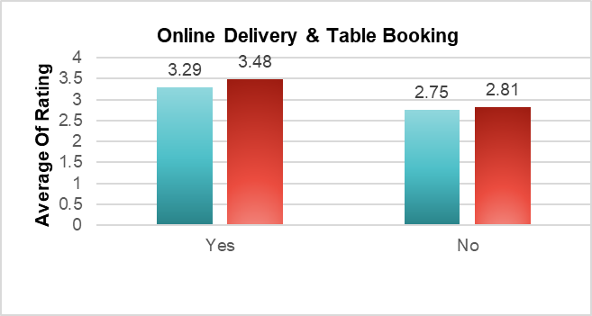

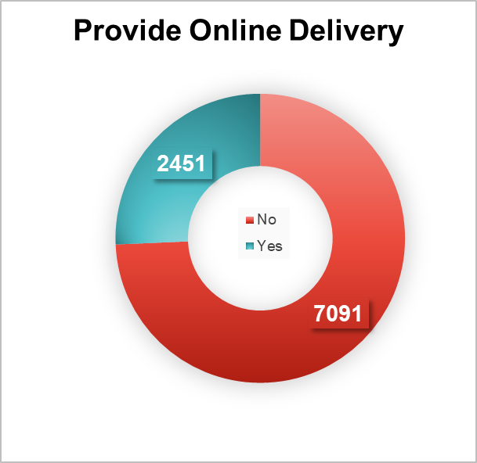
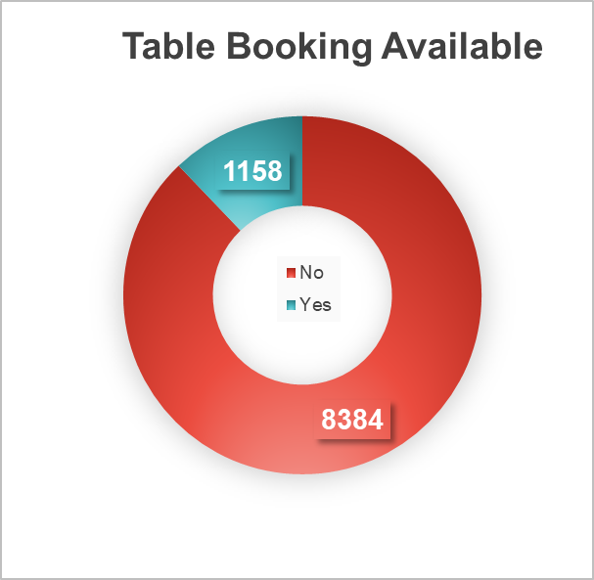
Insights:

- Online delivery: Restaurants with it average 3.29, against 2.75 without it.
- Table booking: Restaurants with it average 3.48, against 2.81 without it.
- Both services go with higher ratings, and table booking shows the bigger gap (0.67 vs 0.54).
- Only about 26% of restaurants offer online delivery (2,451 of 9,542) and only about 12% offer table booking (1,158 of 9,542), so most competitors don't provide them.

Recommendations:

- Offer both online delivery and table booking. Restaurants with these services have higher average ratings (3.29 with online delivery vs 2.75 without, and 3.48 with table booking vs 2.81 without). Very few restaurants offer them (only 26% have online delivery and 12% have table booking), so these services are beneficial.
- Start with table booking. It has the bigger rating gap (0.67, against 0.54 for online delivery), and only 1,158 of 9,542 restaurants offer it.
- Add online delivery as well, so more customers can order from us. Keep food and service quality good, because ratings depend on that too.
- After opening, track our ratings to check whether these services really improve customer feedback.

Question 8: Should the team keep the rate of cuisines higher? Will that affect the feedback? According to our data are the rates of cuisines and ratings, correlated?

Solution:

Approach:
- Select all data from cleaned data sheet by pressing Ctrl+A, then go to pivot table option.
- Create a pivot table with Cuisines in Rows, and Average of Average Cost for Two and Average of Rating in Values.
- Sorted by cost and took the 10 highest-priced cuisines.
- Plotted a combo chart to see whether higher prices go with higher ratings.
- To check correlation, use =CORREL(cost range, rating range) on the cuisine-level data.
Formula used: =CORREL('Cleaned Data'!$Y$2:$Y$9543,'Cleaned Data'!$T$2:$T$9543)

Charts & Tables:

Row Labels | Average of Average-cost-for-two in Rs. | Average of Rating
European, Asian, Indian | 42120 | 4.9
Seafood, American, Mediterranean, Japanese | 21060 | 4.7
Contemporary | 15232 | 4.5
Seafood, Asian, Filipino, Indian | 28080 | 4.4
French | 21034 | 4.2
Chinese, Seafood, Cantonese, Dim Sum | 28782 | 3.9
French, Mediterranean, European | 47970 | 3.8
Asian, Continental, Seafood | 21107 | 3.8
Desserts, Pizza, Ice Cream | 38376 | 3.5
Chinese, Continental, Singaporean | 28782 | 3.4
Grand Total | 26172 | 4.1

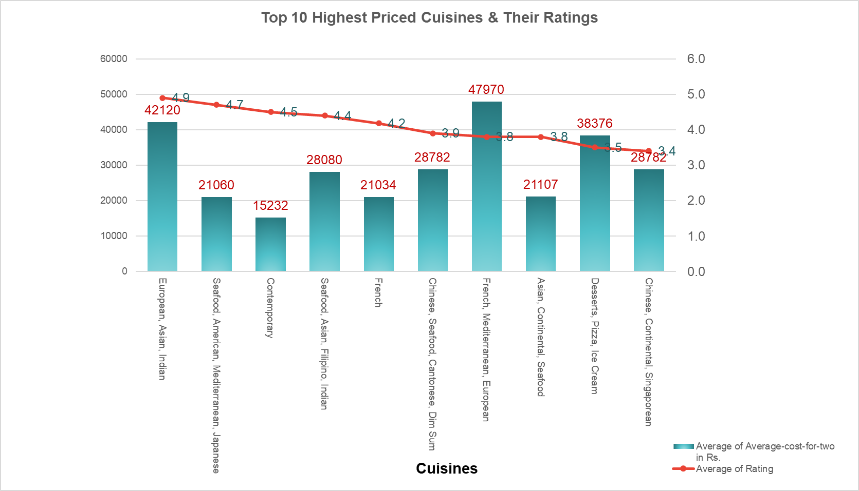

Insights:

- Highest rating: European, Asian, Indian (4.9, cost 42,120).
- Highest cost: French, Mediterranean, European (47,970), but its rating is only 3.8.
- Lowest rating: Chinese, Continental, Singapore (3.4).
- Cost and rating do not rise together, so the correlation is weak.

Recommendations:

- Do not keep prices high just to get better feedback.
- Keep prices reasonable and focus on food quality and service.
- Keep premium pricing only for cuisines that already rate well, like European, Asian, Indian.

Question 9: What is the distribution of the number of restaurants of different price ranges in all the countries?

Solution:

Approach:
- Create a pivot table with Price Range (1 to 4) and Country in Rows, and Count of Restaurant ID in Values.
- Showed the number of restaurants in each price range, split by country, with a grand total of 9,542.

Charts & Tables:

Price Range | Count of RestaurantID
1 | 4438
Australia | 4
Brazil | 2
India | 4295
New Zealand | 3
United Kingdom | 4
United States of America | 130
2 | 3113
Australia | 14
Brazil | 7
Canada | 3
India | 2858
Indonesia | 1
New Zealand | 4
Philippines | 1
Qatar | 1
Singapore | 1
South Africa | 4
Sri Lanka | 6
Turkey | 11
United Arab Emirates | 9
United Kingdom | 28
United States of America | 165
3 | 1405
Australia | 5
Brazil | 16
India | 1111
Indonesia | 20
New Zealand | 17
Philippines | 12
Qatar | 5
Singapore | 5
South Africa | 17
Sri Lanka | 11
Turkey | 18
United Arab Emirates | 29
United Kingdom | 32
United States of America | 107
4 | 586
Australia | 1
Brazil | 35
Canada | 1
India | 388
New Zealand | 16
Philippines | 9
Qatar | 14
Singapore | 14
South Africa | 39
Sri Lanka | 3
Turkey | 5
United Arab Emirates | 22
United Kingdom | 16
United States of America | 23
Grand Total | 9542

Insights:
- Price range 1 has the most restaurants (4,438), then range 2 (3,113), range 3 (1,405) and range 4 (586).
- The number of restaurants falls as the price range rises.
- India has the most restaurants in every price range.
- In our suggested countries, price range 4 is rare (Indonesia has none).

Recommendations:

- Keep most new restaurants in price ranges 1 to 3, where most customers are (about 94%).
- Open one price range 4 (high-end) restaurant as a trial in the suggested countries, because very few restaurants there are in this range.

Question 10: Explain your approach in brief for suggesting countries/cities in order to open new restaurants, if the objective and subjective questions would have not been given to assist you. [you have to give bullet pointers in order to answer this question]

Solution:

Approach:
- Data cleaning: Clean the Zomato dataset, handle missing cuisine values, standardize country names, and validate currency mappings.

- Competition analysis: Compare restaurant counts across Australia, Canada, Indonesia, the Philippines, Qatar, Singapore, and Sri Lanka to identify markets with relatively fewer restaurants.

- Demand and quality analysis: Compare average ratings and votes to identify countries showing positive customer feedback and engagement.

- Pricing analysis: Compare average cost for two after validating currency conversions to understand price levels in each market.

- Cuisine analysis: Evaluate cuisine-level ratings, votes, and restaurant counts to shortlist suitable food concepts for each country.

- Service analysis: Compare ratings and availability of online delivery and table booking to identify potential service opportunities.

- City shortlisting: Identify cities with relatively low competition and promising customer engagement within the selected countries.

- Feasibility assessment: Validate local demand, competition, operating costs, licensing, food regulations, and technology requirements before recommending expansion.

Charts & Tables:
- Table / Chart Name:
<Name of the table or chart used (should align with Excel subsheet names) along with the screenshot of chart or table>
- Description:
The approach is explained in bullet points. The supporting analysis is in Q-1 to Q-9 I Subjective.

Insights:
- Competition alone can mislead. Canada has only 4 restaurants but low ratings (3.6) and low votes (103), so demand looks weak.
- Indonesia and the Philippines have the best mix: few restaurants, high votes and high ratings.
- Mixed currencies and India's 91% share of the data distort simple comparisons.
- Small samples (4 to 24 restaurants per country) make the results indicative only.

Recommendations:

- Indonesia: Prioritize further evaluation because the dataset shows 21 restaurants, an average rating of 4.30, and average votes of 772. Assess Indonesian and Japanese/Sushi concepts using cuisine-level performance.

- Philippines: Prioritize further evaluation with 22 restaurants, an average rating of approximately 4.47, and average votes of 407. Evaluate Filipino, Mexican, and Seafood concepts using local cuisine data.

- Sri Lanka: Consider a cautious pilot, focusing on Colombo and evaluating Seafood, Desserts, and Juices. Validate demand and operating costs before expansion.

- Australia: Consider a single pilot restaurant after validating demand, competition, operating costs, and cuisine-level ratings. Evaluate Mediterranean, Seafood, and Pizza concepts were supported by the data.

- Canada: Consider a small pilot only after further validation, as the dataset contains just 4 restaurants. Test Italian, Mediterranean, and Pizza concepts only after checking the limited cuisine-level evidence.

- Qatar: Evaluate Chinese and Indian cuisine using the available ratings, votes, and restaurant counts. Validate local preferences, competition, and operating costs before investing.

- Singapore: Investigate premium-oriented concepts cautiously because the dataset indicates relatively high average dining costs, but the limited restaurant sample and cuisine-level evidence do not establish profitability. Validate ratings, votes, currency conversion, and local demand before selecting a cuisine.

